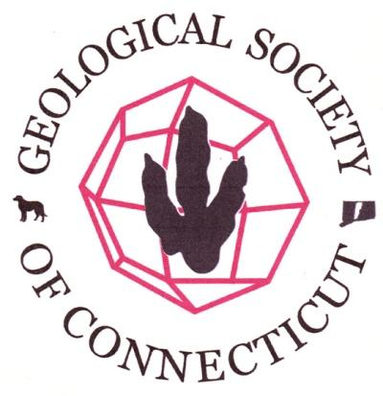

Agenda- Board of Directors Meeting
Geological Society of Connecticut
January 6, 2016, 4:30 PM
Dinosaur State Park, Rocky Hill, CT.

Call to Order: 4:31pm Ralph Lewis, Janet Stone, Margaret Thomas, Fritz Moritz, Meg Enkler, Mike Wizevich, Camille Fontanella, Phil Resor, Drew Hyatt present. Dan Vellone on speaker phone. Peter LeTourneau on Skype.
Old Business: Approval of Minutes - DH moved to approve. ME seconded. Unanimously approved.
New Business,
- Welcome to Phillip and Member/Officer Term Refresher - Attach officer terms that I sent to Ralph. DH will update website.
- Treasurer’s Report - MT Report. FM motioned to approve. JS seconded. Unanimously approved.
        - Annual Meeting
        - How did it go? We have paid CCSU. All agreed it was great that so many students attended. CF reconciled Membership list with list of attendees and payees at the meeting.
        - Committee/Initiative Reports:
        - Membership Issue - JS proposal to separate the dues and the events. DH can automate via the website if we pay extra per year. Debated not to have dues at all or at least no student dues. MT motioned to pay extra for the website administration of membership. DH seconded. Unanimously approved.
        - Student Research Fund (web announcement, etc.) - Already on website. CF to send out email announcement January 10. ME, RL and FM to review the applications.
        - Spring Field Trip (Fritz-RSL) - FM to follow up with DV on guide and fieldtrip. MT volunteered to be the editor for field guide. April 16 is the date.
        - Next Annual Meeting (Dan/Fritz) - Need to finalize agreement with Bakker. FM drafted agreement. Date of meeting will be November 18. DV proposed exclusive cocktail hour tickets to fundraise for lecture fee. PL proposed Wesleyan as venue for meeting. Does Wesleyan want to co-sponsor? PR to find out.
        - Revitalize/Revamp Committees/Elections? - RL established committee for Annual Meeting and Fundraising - members are PR, FM, PL, DV, MW, ME. PR and PL to work on venue for annual meeting. ME and JS to work on catering/drink. FM, MW, DV to work on agreement. DV and JS to work on cocktail hour.
        - State Park Geology Signage Initiative - not discussed.

        - Correspondence/Other Business:

        - Requests for speakers, etc. - Teacher at South Windsor High needs volunteer for Science Olympiad. CT Audobon need presenter for Master Naturalist Program. MT suggested Teresa Gagnon. Suggestion to post speaker requests on website.
        - Discussed using Survey Monkey for future elections so more anonymous.
        - Dino Park 50th- Facebook Program (Meg) is live messaging with lecturers
        - DH has class conflict with Board meeting times for this coming semester.

Next Board Meeting: March 2, 2016
Motion to Adjourn: 6:00pm

