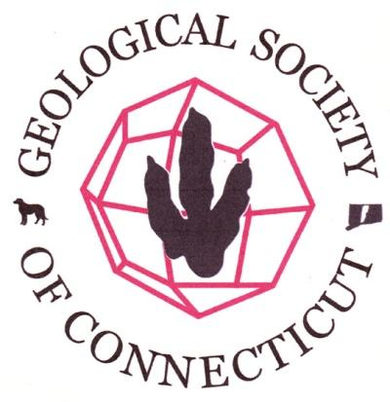

Agenda- Board of Directors Meeting
Geological Society of Connecticut
May 4, 2016, 4:30 PM
Dinosaur State Park, Rocky Hill, CT.

Call to Order: 4:32pm Janet Stone, Camille Fontanella, Phil Resor, Matte Thomas, Meg Enkler, Mike Wizevich, Fritz Moritz, Drew Hyatt (via skype)
Old Business: Approval of Minutes: MT indicated that we printed a guidebook (instead of copied) and charged $10 to all who attended Merguerian fieldtrip. Must fix any typos in draft minutes. Motion to approve minutes with amendments unanimously approved.
New Business:
- Treasurer’s Report - MT pointed out that after the scholarships are paid out, we would only have $21.85 in the scholarship account, so we should consider fund raising for next year’s scholarships (T-shirts or coffee mugs were suggested). Merguerian fieldtrip broke even. Reprinted 100 copies of the Coastal Guidebook. MW requested inventory of copies of guidebooks that we currently possess in reserve. ME motioned to approve report and they were unanimously approved.
        - Nov. Annual Meeting
        - Committee reports and discussion
    - Caterer, Menu Choice, Prices (ME and JS) - student workers to help serve. PR will get in touch with Wesleyan. Unresolved: coffee, plates and cutlery, linens, servers, cleanup, bartender, purchase of alcoholic beverages and water, glassware. Caterer is Cooking Company.
    - Fundraising Plan (DV and JS) - Discussion of cocktail invite only meet & greet prior to normal 5pm happy hour. This would be a separate cost from annual dinner; suggest a max of 25 ppl and charge $40 per person.
    - Wesleyan Role (PR) - PR suggested private cocktail reception could be in classroom of Geology Dept.
    - Pricing for Annual Meeting attendance and pricing for student/public attendance at talk only - Discussion on how to manage those who wish to attend lecture and not the dinner. ME proposed students should be free. PR said that ticket office at Wesleyan might be able to provide tickets to students. FM proposed that just lecture tickets should be $5 for non-students. ME suggested asking for donation at entrance of lecture. JS proposed a later vote on whether or not lecture any year should be open to the public and that the only thing people are paying for at the annual meeting is the social hour and dinner.
    - Timing of events - Discussed ½ hour cocktail reception for fundraising prior to standard happy hour.
    - Memorandum is drafted but still needs to be finalize once Bob’s role is defined. DV asked Bakker for lecture title. FM pointed out that MOU needs highlighted information filled in.
        - Committee Reports:
        - Student Research Fund (ME) - students who received grants have been notified. Checks will be sent soon. Announcement of winners will appear in newsletter.
        - June 11th Field Trip Update (JS) - Similar to NEIGC fieldtrip by Ralph Lewis, Janet Stone, and Phil Resor. Guidebook is in draft to be finalized week of May 9. CF to send out save the date email this weekend. Last year we charged $45 nonmember, $20 for members, $10 for students. Pricing unanimously approved. JS suggested possible social hour at Saybrook Point.
        - April trip post mortem (MT) - not discussed

        - Correspondence/Other Business:
        - Joe Webb Peoples Award nominations - A question has been asked-are current Board members fair game or ruled out? PR suggest going to membership for nominations for this award.
        - Need for future speakers/trips, etc. - DV sent request to the Advisory Panel. MW suggested Bill Burton on Pomperaug Basin and Patrick Getty for dinosaur fieldtrip.
        - Discussion on change of meeting day - Monday seems to be the best day.

Next Board Meeting: July 20, 2016
Motion to Adjourn: 5:58pm

